Weekly Newsletter
  - Ms. Jones social studies
I have no special talent. I am only passionately curious.
-Albert Einstein
DAYS  Monday  Tuesday  Wednesday  Thursday  Friday | CLASS ACTIVITIES  Regions/landforms  Region/vegetation  Regions/population  Regions/economy  Regions/climate |  | HOMEWORK  Label regions  Coloring sheet  No homework  Learn to count coins  No homework
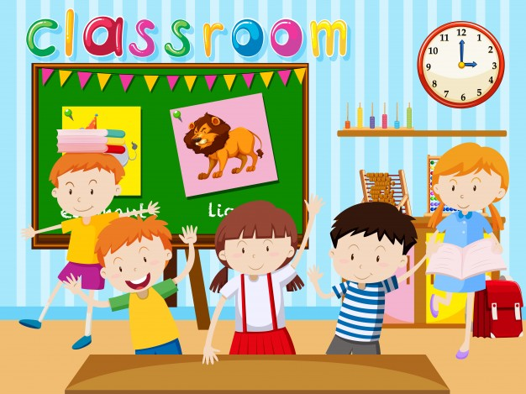 |  | Reminder- Red ribbon week  MONDAY- Camouflage Day  TUESDAY- Dream Career Day  WEDNESDAY- Western Wear Day  THURSDAY- Red Day  FRIDAY- School Pride Day

LUNCH MENU
Contact Information
Ms. Mayra Jones
580 729- 1533
Mayrajones7@gmail.com
MONDAY | Pizza
TUESDAY | Burgers
WEDNEDSY | Tacos
THURSDAY | Hot Dogs
FRIDAY | Spaghetti
SATURDAY | Chicken Nuggets

